QUESTION
Write about Keylogging and Hash Dumping

KEYLOGGING
A keylogging or keystroke logging/keyboard capturing is a form of malware or hardware that keeps track of and records your keystrokes as you type. It takes the information and sends it to a hacker using a command-and-control (C&C) server. The hacker then analyzes the keystrokes to locate usernames and passwords and uses them to hack into otherwise secure systems.

Software keyloggers
Software keyloggers consist of applications that have to be installed on a computer to steal keystroke data. They are the most common method hackers use to access a user’s keystrokes.
A software keylogger is put on a computer when the user downloads an infected application. Once installed, the keylogger monitors the keystrokes on the operating system you are using, checking the paths each keystroke goes through. In this way, a software keylogger can keep track of your keystrokes and record each one.
After the keystrokes have been recorded, they are then automatically transferred to the hacker that set up the keylogger. This is done using a remote server that both the keylogger software and the hacker are connected to. The hacker retrieves the data gathered by the keylogger and then uses it to figure out the unsuspecting user’s passwords.
The passwords stolen using the key logger may include email accounts, bank or investment accounts, or those that the target uses to access websites where their personal information can be seen. Therefore, the hacker’s end goal may not be to get into the account for which the password is used. Rather, gaining access to one or more accounts may pave the way for the theft of other data.

Hardware keyloggers
A hardware keylogger works much like its software counterpart. The biggest difference is hardware keyloggers have to be physically connected to the target computer to record the user’s keystrokes. For this reason, it is important for an organization to carefully monitor who has access to the network and the devices connected to it.
If an unauthorized individual is allowed to use a device on the network, they could install a hardware keylogger that may run undetected until it has already collected sensitive information. After hardware keystroke loggers have finished keylogging, they store the data, which the hacker has to download from the device.
The downloading has to be performed only after the keylogger has finished logging keystrokes. This is because it is not possible for the hacker to get the data while the key logger is working. In some cases, the hacker may make the keylogging device accessible via Wi-Fi. This way, they do not have to physically walk up to the hacked computer to get the device and retrieve the data.
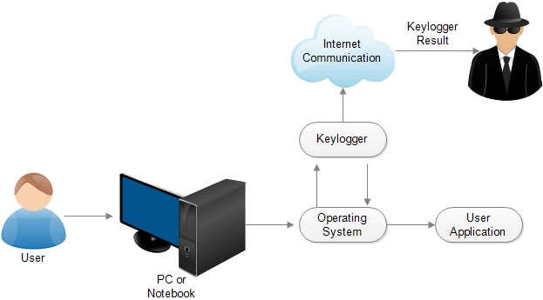

https://www.google.com/search?sca_esv=ec9b7aa65a40aa8b&sxsrf=AHTn8zqUxdzziP15afdxHM3Ltemu_rPONg:1743410201656&q=Keylogging+diagram&udm=7&fbs=ABzOT_CWdhQLP1FcmU5B0fn3xuWpA-dk4wpBWOGsoR7DG5zJBkzPWUS0OtApxR2914vrjk4ZqZZ4I2IkJifuoUeV0iQt1uortC3ar_w-QplxoC-7ph9F8Vj2YeEsC6afClCFefF-cmpw5c4zhgFPwral85LY2zgFf8UOMx3_ZIjDM7HssES5AkdS0tSTRiscJb9b7pke_zKMHRdan7x9bthMa_dZ3GZE1A&sa=X&ved=2ahUKEwiGxpGO9bOMAxUYh_0HHWSUFY4QtKgLegQICxAB&biw=980&bih=498&dpr=1#
Visit the link above to learn more about the practicality of keylogging

HASH DUMPING
Hash dumping refers to the extraction and collection of password hashes from a computer system or network. Password hashes are the encrypted or mathematically transformed versions of passwords stored in a system's database. Rather than storing actual plaintext passwords, systems store these hash values for security purposes.
Key aspects of hash dumping include:
1. Purpose: Hash dumps are typically created for one of two reasons:
- Legitimate security testing and password auditing by system administrators
- Malicious extraction by attackers who aim to crack the hashes offline
2. Common targets: Hash dumping often targets:
- Windows systems (SAM database and NTDS.dit)
- Linux/Unix systems (/etc/shadow)
- Web applications (database password tables)
- Active Directory environments
3. Common techniques and tools:
- Mimikatz (extracts hashes from memory)
- Hashdump modules in penetration testing frameworks
- Registry extraction tools
- Memory forensics tools
- LSASS process dumping
4. Security implications:
- Once obtained, hashes can be subjected to offline cracking attempts
- Certain hash formats are more vulnerable than others
- Pass-the-hash attacks might be possible without cracking

5. Defensive measures:
- Credential Guard and other memory protection technologies
- Strong password policies to resist cracking
- Privileged access management
- Advanced monitoring for hash dumping activities

https://www.google.com/search?sca_esv=ec9b7aa65a40aa8b&sxsrf=AHTn8zo7ojhcVrBjwLHjQIWx16NQCW8GOw:1743410296172&q=Hash+Dumping+diagram&udm=7&fbs=ABzOT_CWdhQLP1FcmU5B0fn3xuWpA-dk4wpBWOGsoR7DG5zJBkzPWUS0OtApxR2914vrjk4ZqZZ4I2IkJifuoUeV0iQt1uortC3ar_w-QplxoC-7ph9F8Vj2YeEsC6afClCFefF-cmpw5c4zhgFPwral85LY2zgFf8UOMx3_ZIjDM7HssES5AkdS0tSTRiscJb9b7pke_zKMHRdan7x9bthMa_dZ3GZE1A&sa=X&ved=2ahUKEwjOr5q79bOMAxWh87sIHU8yH9EQtKgLegQIDBAB&biw=980&bih=498&dpr=1#
Visit the link above to learn more about the practicality of hash dumping

